

**BOOKSHOP MANAGEMENT SYSTEM**

*A Mini Project report submitted in partial fulfillment of the requirement for the completion of the course*

**PROBLEM SOLVING USING C**

*Submitted*

*By*

**P.ROHIT SIVA SAI KUMAR**

**JNTU No:16341A0818**

*Under the esteemed guidance of*

**Mr. P.MURALIDHARA RAO SIR,**

**Assistant Professor,**

**CSE**

**Department of Basic Sciences & Humanities**

**GMR INSTITUTE OF TECHNOLOGY**

(An Autonomous institute, affiliated to J.N.T.University Kakinada)

NAAC “A” Graded, NBA Accredited, ISO 9001:2008 Certified Institution

G.M.R. Nagar, Rajam-532127, A.P

**2016-17**



**GMR INSTITUTE OF TECHNOLOGY**

(An Autonomous institute, affiliated to J.N.T. University Kakinada)

NAAC “A” Graded, NBA Accredited, ISO 9001:2008 Certified Institution

G.M.R. Nagar, Rajam-532127, A.P

**DEPARTMENT OF BASIC SCIENCES AND HUMANITIES**

**CERTIFICATE**

*This is to certify that Mini Project report titled* **“Book Shop Management”** *submitted by* **P.Rohit Siva Sai Kumar** *bearing***Reg. No 16341A0818** *has been carried out in partial fulfillment for the completion of the course “PROBLEM SOLVING USING C” in* **B.Tech Semester 2** *is a record of bona fide work carried out under the guidance and supervision of “****P.Muralidhara Rao Sir****”*

Signature of the Supervisor Signature of the Course Coordinator

**Mr.P.Muralidhara Rao Sir , Ms.M.Suneetha**

Assistant Professor,. Assistant. Professor,

Department of CSE, Department of IT,

GMRIT, Rajam. GMRIT, Rajam.

**ACKNOWLEDGEMENT**

It gives us an immense pleasure to express deep sense of gratitude to my guide, **P.Muralidhara Rao Sir ,Assistant Professor**, Department of Computer Science Engineering of whole hearted and invaluable guidance throughout the report. Without his sustained and sincere effort, this report would not have taken this shape. He encouraged and helped us to overcome various difficulties that we have faced at various stages of our report.

We would like to sincerely thank **Dr. D Krishna Rao Sir,** Professor & HOD, Department of Basic Sciences & Humanities, for providing all the necessary facilities that led to the successful completion of our report.

We take privilege to thank our Principal **Dr. C.L.V.R.S.V.Prasad Sir** & Vice Principal **Dr. J. Murugadoss Sir**, who has made the atmosphere so easy to work. We shall always be indebted to them.

We would like to thank all the faculty members of the Department of Computer Science Engineering for their direct or indirect support and also all the lab technicians for their valuable suggestions and providing excellent opportunities in completion of this report.

**P.Rohit Siva Sai Kumar**

**JNTU No:16341A0818**

INDEX

**CONTENTS PAGE NO**

ABSTRACT ……… 5

1. OBJECTIVE ……… 6

2. INTRODUCTION ……… 7

3. EXPERIMENTAL SETUP ……… 8

4. RESULTS & DISCUSSION ……… 21

5. CONCLUSION ……… 23

BIBILOGRAPHY & REFERENCES ……… 24

ABSTRACT

All the Book Shop Keepers can use our project to run their store easily. By using this project they can store all the info. Related with the books available in the store. They can also search a particular book easily by getting the info. From the project. In this we also define the information of all the customers who wants to purchase the books from their store. In this they can also store the info. Of all the orders of all those books which are not available in the store. Because of this computerization, any book store owner can run their store easily in User friendly Environment.

OBJECTIVE

This Book Shop Management System is used to overcome the entire problem which they are facing currently, and making manual system to computerized system. Purposed Book shop management system should help the customers query whether a book in a stock the user can query the availability of a book either by using the book title or by using the name of author.

The Main objectives of this project are:

• Reduction of paper work

• Automation of existing manual information systems.

• Reduction of manual processing

• Keep track of daily information exchange at the server by the administrator.

• Increase in processing and transfer speeds of information over the network.

• Decrease in processing time

• Reduction of errors and viruses due to absence of internet

• Keeping track that message should be delivered at the correct destination.

• Fast retrieval of all type of information

• Good efficiency and response time

• More consistent data handling

• A user-friendly system which do not require any special training or expertise of computer

INTRODUCTION

Book Store Management System is the web application to automate all kinds of operations in the book shop. The purpose of this software is to manage the books in the book store. Generally, it includes the Order Processing, Stock Management and Accounts Management. We developed this software to maintain records of sales, purchase and staff records. This project developed using ASP.NET as front end and SQL Server as Back end. Here we are try to develop such type system which is provide the automation on the any type of the bookshop. That means a shop which has the type system which provides the facility to the customers of the shop to purchase the books from the shop without any complexity.  
  
At the start of the business, the books store owner buys the book from the dealers. All the name of the books is noted down in the software along with rate. In the present system user has to do all work manually. In present system During issuing order of more stock, the product register is required to check to availability of stock in hand. And it takes time to check records.   
  
The amount paid to a particular dealer from whom the book was bought is also saved in the dealers tab. In present book store management system, To generate the reports based on the management requirement, will require extensive searching of records. In case of Supplier and Staff Record Management, the registers need to be updated time to time as information (like Phone No., Address) changes frequently. The stock section gives the total number of book stocks available in the store. When a customer buys a book from the store, a bill is generated. The bill contains the name of the book purchased, rate per book, quantity, total rate and the total amount. For example any customer want to purchase any book from the shop than first of all customer just choose the stream of the book than he/she can see the more than one type of books there and then he/she can choose the specific book from there. And then purchase it by paying price on bookshop cash counter and receives its invoice.  
  
For the next month, the owner will get estimation as to which book to purchase more and which book to purchase less and which books not to purchase. In present book store management system, In each process whether it is Product Management, Maintaining Customer Records, Payment Management, Report Generation, user has to pay attention to a greater extent while performing the tasks. In purposed system all records are saved in the database for report generation. Depending upon the number of books purchased, the number of books from the stock will be deducted. Therefore we get the total number of books sold from the stock. In present system user has to maintain Customers Records manually. He has to maintain suppliers and staff records. He has to generate Present monthly, quarterly or annual Reports.

EXPERIMENTAL SETUP

**HARDWARE REQUIREMENTS**  
  
The hardware that is needed for our system is:  
  
Processor (CPU)                      :        Pentium Processor          
Primary Memory (RAM)        :        64 MB              
Hard Disk Drive                     :        20 GB  
Display Size                           :        14 ’’ Monitor  
Text Resolution                      :        80 Columns by 25 Rows   
Key Board                              :         Total 104 keys with 12   
                                                          Functions keys              
  
 **SOFTWARE REQUIREMENTS**  
  
 The software that is needed for our system is:

* **TURBO C++**
* **MICROSOFT PROCESSER**

**SOURCE CODE:**

#include<stdio.h>

#include<conio.h>

#include<process.h>

#include<string.h>

//the library functions are included to the program.

//a structure has been defined which is used to maintain the details of any book

typedef struct

{

char book_name[30]; //declaring a structure

char author[30];

int b_id;

int a_id;

int copy;

float price;

}book; //the structure is of type book

book records; //a variable records of type book is globally declared

void administrator(book records); //function prototype

void user (book records); //function prototype

//starting of the main program

void main()

{

int i; //variable declaration

char str[10]; //variable declaration

while(1)

{

clrscr();

gotoxy(30,10);

printf("PRESS 1 IF YOU ARE USER");

gotoxy(30,12);

printf("PRESS 2 TO IF YOU ARE AN ADMINISTRATOR");

gotoxy(30,14);

printf("PRESS 0 TO EXIT");

printf(" ENTER YOUR CHOICE :");

fflush(stdin); //clearing the input buffer

scanf("%d",&i); //taking input for required choice

switch (i) //starting of switch case

{

case 1: user(records); //calling the user function to perform required tasks by the user

break;

case 2: printf(" ENTER THE PASSWORD(IN CAPITAL LETTER) :");

scanf("%s",str); //taking the password as input

if(strcmp(str,"BOOKSHOP")==0)

{ //matching the password given as input with the stored password {

administrator(records); //calling administrator function to perform required tasks by him

}

else

{

printf(" INVALID USER");

getch();

break;

}

case 0: exit(0); //termination of program

}//end of switch case

}//end of while

} //end of main function

void administrator(book records)

{

FILE *p,*t,*q,*r; //declaring file pointer

char an , b; //variable

int i,c,m,n=0;

int a; //declaration

static float sum;

long int recsize;

p=fopen("book.c","rb+"); //opening a file in read mode...the file contains information about different books

if (p==NULL)

{

p=fopen("BOOK.C","wb+"); //opening the file in write mode

if(p==NULL)

{

puts("cannot open file");

getch();

exit(0);

}

}

t=fopen("DEMAND.C","rb+");//opening the file in read mode...the file contains information about the demanded books

if(t==NULL)

{

t=fopen("DEMAND.C","wb+"); //opening

if(t==NULL)

{

puts("cannot open file");

getch();

exit(0);

}

}

q=fopen("BALANCE.C","rb+"); //opening a file for transaction//

if(q==NULL)

{

q=fopen("BALANCE.C","wb+"); //the file is opened in writing mode

if(q==NULL)

{

puts("CANNOT OPEN FILE");

getch();

exit(0);

}

}

recsize=sizeof(records);

while(1)

{

clrscr();

printf("PRESS 1 TO INSERT INTO ANY BOOK\n");

printf("PRESS 2 TO LIST ALL BOOKS\n");

printf("PRESS 3 TO INSERT INTO DEMAND LIST\n");

printf("PRESS 4 TO LIST DEMAND BOOKS\n");

printf("PRESS 5 TO MODIFY ANY RECORD\n");

printf("PRESS 6 TO INSERT INTO TRANSACTION DETAILS\n");

printf("PRESS 7 TO LIST TRANSACTION DETAILS\n");

printf("PRESS 8 TO DELETE ANY RECORD\n");

printf("PRESS 0 TO EXIT\n");

printf("enter your choice");

fflush(stdin);

scanf("%d",&i); //taking input to perform the specific operation

switch(i)

{

case 1: fseek(p,0,SEEK_END); //keep the file pointer at the end of file

an='y';

while(an=='y')

{

printf(" ENTER BOOK NAME(IN CAPITAL LETTER):"); //taking input of the book nam,author name,

scanf("%s",records.book_name); //and other required informations about

printf(" ENTER AUTHOR NAME(IN CAPITAL LETTER) :"); // any book

scanf("%s",records.author);

printf(" ENTER BOOK ID :");

scanf("%d",&records.b_id);

printf(" ENTER AUTHOR ID :");

scanf("%d",&records.a_id);

printf(" ENTER NUMBER OF COPIES :");

scanf("%d",&records.copy);

printf(" ENTER THE PRICE :");

scanf("%f",&records.price);

fwrite(&records,recsize,1,p); // writing the input data into the file in binary format

printf(" ADD ANOTHER RECORD (y/n)");

fflush(stdin); //clearing the input buffer

an=getche();

} //end of while

break;

case 2: rewind(p); //keeps the file pointer at the startinf of file

while(fread(&records,recsize,1,p)==1) //reads the data from the file

{

printf(" BOOK NAME=%s",records.book_name); //displaying the

printf(" BOOK ID=%d",records.b_id); //book details

printf(" AUTHOR NAME=%s",records.author);

printf(" AUTHOR ID=%d",records.a_id);

printf("NUMBER OF COPIES=%d",records.copy);

printf(" PRICE=%f",records.price);

printf(" ");

}//end of while

getch();

break;

case 3: fseek(t,0,SEEK_END); //keep the file pointer at the end of file

an='y';

while(an=='y') //to continue input taking

{

printf(" ENTER BOOK NAME(IN CAPITAL LETTER) :"); //taking input of the required books that are not available

scanf("%s",records.book_name);

printf(" ENTER AUTHOR NAME(IN CAPITAL LETTER) :");

scanf("%s",records.author);

printf(" ENTER THE NUMBER OF COPIES :");

scanf("%d",&records.copy);

fwrite(&records,recsize,1,t); //writing the input data to the file in binary format

printf(" ADD ANOTHER RECORD (y/n)");

fflush(stdin); //clearing the input buffer

an=getche(); //displays the character to be entered

}//end of while

break;

case 4:rewind(t); //keep the file pointer at the starting of file

while(fread(&records,recsize,1,t)==1) //reads the data from the file

{

printf(" BOOKNAME=%s",records.book_name); //display the required books

printf(" AUTHOR NAME=%s",records.author);

printf(" NUMBER OF COPIES=%d",records.copy);

printf(" ");

}//end of while

getch();

break;

case 5: an='Y';

while(an=='Y')

{

printf("ENTER THE BOOK ID TO MODIFY :");

scanf("%d",&a);

while(fread(&records,recsize,1,p)==1)

{

if(records.b_id==a)

{

printf(" ENTER BOOK NAME :"); //taking input of the book nam,author name,

scanf("%s",records.book_name); //and other required informations about

printf(" ENTER AUTHOR NAME :"); // any book

scanf("%s",records.author);

printf(" ENTER BOOK ID :");

scanf("%d",&records.b_id);

printf(" ENTER AUTHOR ID :");

scanf("%d",&records.a_id);

printf(" ENTER THE NUMBER OF COPIES :");

scanf("%d",&records.copy);

printf(" ENTER THE PRICE :");

scanf("%f",&records.price);

fseek(p,-recsize,SEEK_CUR);

fwrite(&records,recsize,1,p); //writing the modified record in the file

break;

}//end of if

}//end of while

printf(" MODIFY ANOTHER RECORD(Y/N) :");

fflush(stdin); //clearing input buffer

an=getche(); //the character will be displayed on screen

}//end of while

break;

case 6: an='Y';

while(an=='Y')

{

fseek(q,0,SEEK_END); //placing the pointer at the end of file

printf(" BOOK NAME( IN CAPITAL LETTER) :"); //taking input

scanf("%s",records.book_name);

printf(" BOOK ID:");

scanf("%d",&records.b_id);

printf(" NO OF SOLD COPY :");

scanf("%d",&records.copy);

printf(" ENTER THE PRICE OF ONE COPY :");

scanf("%f",&records.price);

fwrite(&records,recsize,1,q); //writing the record in file

printf(" ADD ANOTHER RECORD(Y/N)");

fflush(stdin); //clearing the input buffer

an=getche();

}//end of while

break;

case 7: rewind(q); //the pointer is placed at the first position of file

while(fread(&records,recsize,1,q)==1) //reading the data from file

{

printf(" BOOKNAME=%s",records.book_name);//displaying the records

printf(" BOOK ID=%d",records.b_id);

printf(" PRICE OF ONE COPY=%f",records.price);

printf(" NO OF SOLD COPY=%d",records.copy);

}//end of while

getch();

break;

case 8: an='Y';

while(an=='Y')

{

printf("ENTER THE BOOK ID TO DELETE :");

scanf("%d",&b);

r=fopen("TEMP.C","wb"); //a temporary file has benn opened

rewind(p);

while(fread(&records,recsize,1,p)==1) //readind the data

{

if(records.b_id!=b)

{

n++;

fwrite(&records,recsize,1,r); //writing records in temporary file

}//end of if

}//end of while

fclose(p); //file is colsed

fclose(r);

remove("BOOK.C"); //original file is deleted

rename("TEMP.C","BOOK.C"); //temporary file is remaned

p=fopen("BOOK.C","rb+");

printf(" DELETE ANOTHER RECORD(Y/N)");

fflush(stdin);

an=getche();

}//end of while

getch();

break;

case 0: fclose(p); //closing the file BOOK.C

fclose(t); //closing the file DEMAND.C

fclose(q); //closing the file BALANCE.C

exit(0);

}//end of switch

}//end of while

}//end of administrator function

void user(book records)

{

FILE *p,*t; //declaring file pointer

char arr[30];

int an; //variable declaration

int i,e,cp,m,ch;

int n=0;

p=fopen("BOOK.C","rb+"); //opening the file containing book details in read mode

if(p==NULL)

{

p=fopen("BOOK.C","wb+");

if(p==NULL)

{

puts("CANNOT OPEN FILE");

getch();

exit(0);

}

}

t=fopen("DEMAND.C","rb+"); //opening the file in read mode

if(t==NULL)

{

t=fopen("DEMAND.C","wb+"); //opening the file in write mode

if(t==NULL)

{

puts("CANNOT OPEN FILE");

getch();

exit(0);

}

}

while(1)

{

clrscr();

gotoxy(30,8);

printf("PRESS 1 TO SEARCH BY BOOK NAME ");

gotoxy(30,10);

printf("PRESS 2 TO SEARCH BY AUTHOR NAME ");

gotoxy(30,12);

printf("PRESS 0 TO EXIT");

gotoxy(30,16);

printf("ENTER YOUR CHOICE:");

fflush(stdin);

scanf("%d",&i); //taking input from user

switch(i)

{

case 1: printf(" ENTER THE BOOK NAME(IN CAPITAL LETTER):");

scanf("%s",arr); //taking the bok name from user

rewind(p);

while(fread(&records,sizeof(book),1,p)==1) //reading the data from file

{

if(strcmp(records.book_name,arr)==0) //comparing the data with input book name

{

printf(" BOOKNAME=%s",records.book_name); //displaying the required results

printf(" AUTHOR=%s",records.author);

printf(" BOOK ID=%d",records.b_id);

printf(" PRICE=%f",records.price);

}//end of if

}//end of while

printf(" DO YOU FIND REQUIRED BOOK(1 for yes/2 for no)");

scanf("%d",&ch) ; //check for finding books

if(ch==1)

{

printf(" ENTER THE BOOK ID :");

scanf("%d",&e);

printf(" ENTER THE NO. OF COPIES YOU WANT :");

scanf("%d",&cp); //input for required copies

rewind(p); //place the pointer at first position

while(fread(&records,sizeof(book),1,p)==1) //reading the data from file

{

if(records.b_id==e) //comparing the book id with the input

{

m=records.copy-cp ; //calculating the remaining books after selling

if(m<0) //checking for availability of books

{

printf(" ALL THE COPIES ARE NOT AVAILABLE");

break;

}

printf(" COPIES ARE AVAILABLE");

}

} //end of while

}//end of if

if(ch==2)

{

printf(" DO YOU WANT TO GIVE ANY DEMAND?(1 FOR YES/2 FOR NO)"); //for giving demand

scanf("%d",&an);

if(an==1)

{

fseek(t,0,SEEK_END); //placing the pointer at the end of file

printf(" BOOK NAME (IN CAPITAL LETTER) :");

scanf("%s",records.book_name);

printf(" ENTER AUTHOR NAME (IN CAPITAL LETTER) :");

scanf("%s",records.author);

printf(" ENTER THE NO OF COPY :");

scanf("%d",&records.copy);

fwrite(&records,sizeof(book),1,t); //writing the record into file

printf(" YOUR DEMAND HAS BEEN PLACED SUCCESSFULLY");

}//end of if

if(an==2)

{

printf(" THANKS FOR YOUR CHOICE");

} //end of if

}//end of if

getch();

break;

case 2: printf(" ENTER THE AUTHOR NAME(IN CAPITAL LETTER):");

scanf("%s",arr); //taking input the author name

rewind(p);

while(fread(&records,sizeof(book),1,p)==1) //reading the data from file

{

if(strcmp(records.author,arr)==0) //comparing the input with the data of file

{

printf(" BOOKNAME=%s",records.book_name);//displaying the required results

printf(" AUTHOR=%s",records.author);

printf(" BOOK ID=%d",records.b_id);

printf("PRICE=%f",records.price);

} //end of if

} //end of else

printf(" DO YOU FIND REQUIRED BOOK(1 for yes/2 for no)");

scanf("%d",&ch);

if(ch==1)

{

printf(" ENTER THE BOOK ID :");

scanf("%d",&e);

printf(" ENTER THE NO. OF COPIES YOU WANT :");

scanf("%d",&cp);

rewind(p); //place the pointer at the first position of file

while(fread(&records,sizeof(book),1,p)==1) //reading the data from file

{

if(records.b_id==e) //comparing the book id with the input

{

m=records.copy-cp; //calculating the no of copies after selling

if(m<0) //check for availability

{

printf(" ALL THE COPIES ARE NOT AVAILABLE");

break;

} //end of if

printf(" COPIES ARE AVAILABLE");

}//end of if

}//end of while

}//end of if

if(ch==2)

{

printf(" DO YOU WANT TO GIVE ANY DEMAND?( 1 FOR YES / 2 FOR NO)");

scanf("%d",&an); //for demand giving

if(an==1)

{

fseek(t,0,SEEK_END); //placing the pointer at the end of file

printf(" BOOK NAME (IN CAPITAL LETTER) :"); //taking input

scanf("%s",records.book_name);

printf(" ENTER AUTHOR NAME (IN CAPITAL LETTER) :");

scanf("%s",records.author);

printf(" ENTER THE NO OF COPY :");

scanf("%d",&records.copy);

fwrite(&records,sizeof(book),1,t); //writing the data into file

printf(" YOUR DEMAND HAS BEEN PLACED SUCCESSFULLY");

}//end of if

if(an==2)

{

printf(" THANKS FOR YOUR CHOICE");

} //end of if

} //end of if

getch();

break;

case 0: fclose(p); //closing the file BOOK.C

fclose(t); //closing the file DEMAND.C

exit(0);

} //end of switch

} //end of while

} //end of user function

RESULTS & DISCUSSION

OUTPUT 1:ENTERING PASSWORD AS AN ADMINISTRATOR

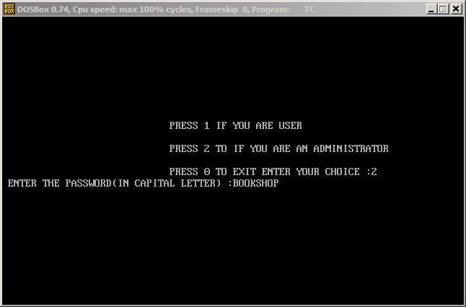

OUTPUT 2:INSERTING A BOOK RECORD

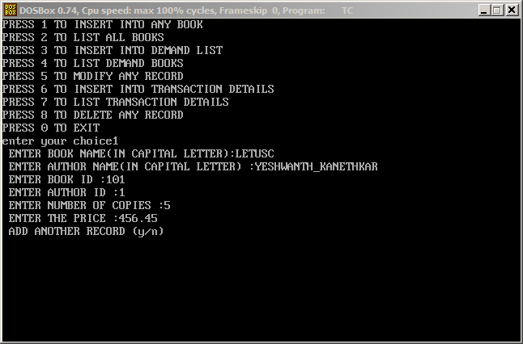

OUTPUT 3:LIST OF BOOK RECORDS

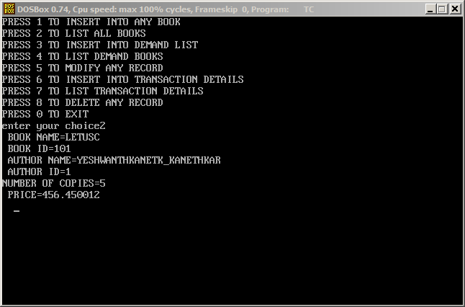

OUTPUT 4:DELETING A BOOK RECORD

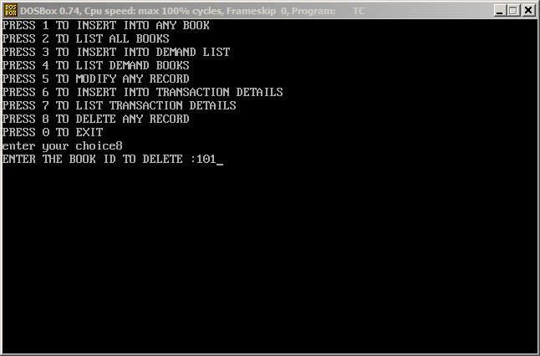

CONCLUSION

Thus with the help of Book Shop Management, the Book Shop Keepers can use our project to run their store easily. By using this project they can store all the info. Related with the books available in the store. They can also search a particular book easily by getting the info. From the project. In this we also define the information of all the customers who wants to purchase the books from their store. In this they can also store the info. Of all the orders of all those books which are not available in the store. Because of this computerization, any book store owner can run their store easily in User friendly Environment.. BIBILOGRAPHY & REFERENCES

WEBSITES REFERRED:

[www.connect2compute.com](http://www.connect2compute.com)

[www.google.com](http://www.google.com)

[www.bookindia.com](http://www.bookindia.com)

[www.codewithc.com](http://www.codewithc.com)